Epoch 1/10
438/438 - 4s - 9ms/step - accuracy: 0.9194 - loss: 0.2703
Epoch 2/10
438/438 - 3s - 7ms/step - accuracy: 0.9668 - loss: 0.1078
Epoch 3/10
438/438 - 3s - 6ms/step - accuracy: 0.9753 - loss: 0.0763
Epoch 4/10
438/438 - 3s - 7ms/step - accuracy: 0.9811 - loss: 0.0595
Epoch 5/10
438/438 - 3s - 7ms/step - accuracy: 0.9843 - loss: 0.0477
Epoch 6/10
438/438 - 3s - 7ms/step - accuracy: 0.9861 - loss: 0.0412
Epoch 7/10
438/438 - 3s - 7ms/step - accuracy: 0.9880 - loss: 0.0363
Epoch 8/10
438/438 - 3s - 6ms/step - accuracy: 0.9896 - loss: 0.0314
Epoch 9/10
438/438 - 3s - 7ms/step - accuracy: 0.9906 - loss: 0.0276
Epoch 10/10
438/438 - 3s - 6ms/step - accuracy: 0.9912 - loss: 0.0260
[1m438/438[0m [32m━━━━━━━━━━━━━━━━━━━━[0m[37m[0m [1m1s[0m 2ms/step

Model evaluation of random forest:
Accuracy: 0.9675
Precision: 0.9675018656506922
Recall: 0.9675
F1 Score: 0.9674871124026196

Model evaluation of ANN:
Accuracy: 0.9781
Precision: 0.9783783585132869
Recall: 0.9781428571428571
F1 Score: 0.9781451226348142

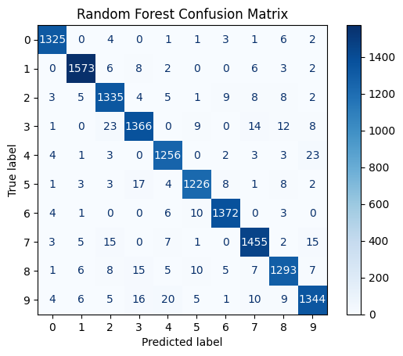
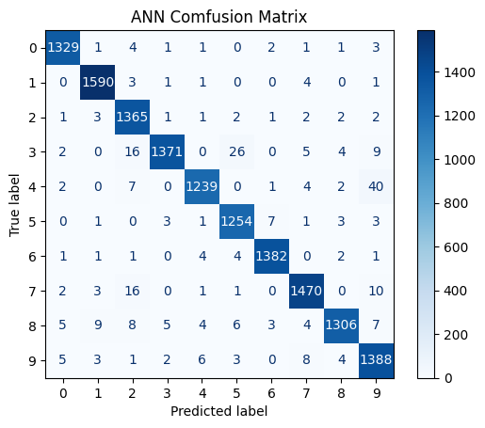
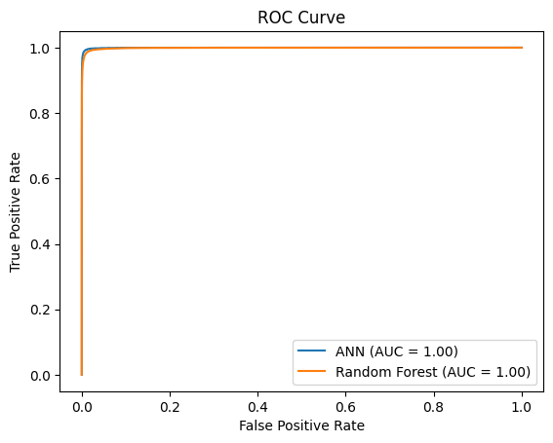
Model evaluation of AdaBoost:
Accuracy: 0.7376
Precision: 0.7387530522686281
Recall: 0.7376428571428572
F1 Score: 0.7335574625096599
